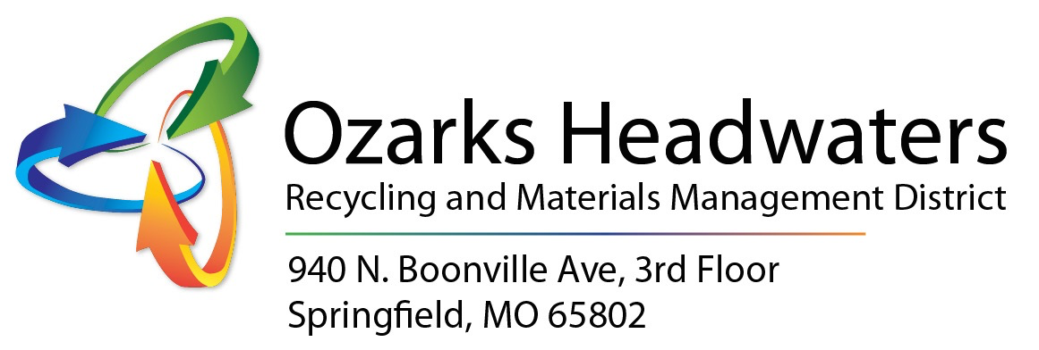

OHRD 2020 Grant Application

Name of Business or Organization
Name of Project
Amount Requested
Estimated Project Income if any.
(All income is to be reinvested in the project).
Partial Funding - The Executive Board reserves the right to only offer partial funding for projects, regardless of ranking | _____ Able to accept partial funding for project to be completed  _____ Not able to accept partial funding for project. (Without full funding, the project will not be able to be completed)
MO Vendor # OR Federal Tax ID # OR SSN # of Owner
This Project is: Check One | ___ An expansion of a current business  ___ A new business  ___ A new venture for an existing business  ___ Other
Type of Applicant - Check One | ___Individual  ___Public Entity or Institution  ___School  ___Business  ___Non-Profit Organization  ___Other (Describe)
Location(s) Of Project
District Counties/Cities that will be served

Project Description
1,000 characters or less

Estimated Tonnage Diverted
During 24 Month Grant Period
Type of Waste Diverted
Other Measurable Outcomes
Name of Authorized Official
Authorized Official Title
Mailing Address
Telephone
Cell Phone (not required)
Email
Web-site
Name of Project Manager
If different than Authorized Official
Project Manager Title
Mailing Address
Telephone
Email
Project Evaluation
Please describe how the project will be evaluated to measure successes and/or benefits of the project.
- Describe the procedure that will be used to quantitatively measure the success and/or benefits of the project.
  - Measurements should include estimated weight in tonnages or volume of waste recycled or diverted.
  - If tonnages are not relevant to the project, then measurement should include, for example the number of schools or assemblies reached, businesses participating, etc.
- If applicable, describe the evaluation procedures that will be used to qualitatively measure the success of the project. For example, community surveys that can determine quality of service.

For educational projects, list the estimated number of people educated/contacted, number of programs conducted, etc.:
Executive Summary of the project

Ineligible Costs - Is the application free of all ineligible costs listed?
Operating Expenses not directly related to district operation or project activities | ___ Yes ____No
Costs incurred prior to the project start date or after project end date | ___ Yes ____No
Taxes, legal costs, fines, penalties, and gifts | ___ Yes ____No
Contingency funds | ___ Yes ____No
Land Acquisition | ___ Yes ____No

Previous Funding - Has your organization received funding from OHRD, EIERA, or other Solid Waste Districts in the past five years? If yes, please list the grant awarded, grant/project number, amount of grant award.
Year Awarded | Project Number | Project Name | Amount Awarded
Qualifications of Key Personnel
Provide a summary of the project manager’s specific qualifications to operate the project, such as managerial, operation or technical capabilities. Include qualifications for other key staff involved in the project. Use additional sheets if necessary. Resumes may be submitted instead.
Line Item Budget

Line Item | Quantity | Price | Total | Grant Funds Requested
Total Budget

Time Table/Work Plan
Month: | 1 | 2 | 3 | 4 | 5 | 6 | 7 | 8 | 9 | 10 | 11 | 12 | 13 | 14 | 15 | 16 | 17 | 18 | 19 | 20 | 21 | 22 | 23 | 24
Task #1:
Task #2:
Task #3:
Task #4:
Task #5:
Task #6:
Task #7:
Task #8: Submit Quarterly Reports reports.
Task #9: Submit Final Report.
See Grant Expenditure Reimbursement Instructions for more details.

Signature Page

OHRD 2020 Grant Cycle - 15% Retention Waiver Form

Per Missouri Department of Natural Resources’ General Terms & Conditions and in accordance with OHRD policy, I hereby request a waiver of the 15% retainage on the project as described in our 2020 District Grant Application.

Project Reporting Requirements
If approved for funding as a 2020 OHRD Grantee, we subsequently agree to furnish Waste Diversion, Waste Reduction, Quarterly Reports, and/or any other information relevant to the project objective for two full years after the project becomes fully operational or other date as specified by Ozarks Headwaters Recycling & Materials Management District.

OHRD 2020 Grant Cycle – 5 Year Reporting Requirement

The Grantee hereby agrees that any equipment purchased pursuant to this agreement shall be used for the performance of services under the agreement during the term of this agreement, and for four years thereafter. The Grantee shall annually submit a statement as provided by the District certifying the use(s) of said equipment is for project activities.

Project Income
We agree that if there is any project income, it is to be reinvested in the project.

Security Interest Agreement

The Grantee will grant to OHRD and/or its successors a security interest in all equipment purchased by the OHRD Grantee for $5,000 or more, in whole or in part, with grant funds received from OHRD.
The security interest in equipment owned by the OHRD Grantee shall be equivalent to the amount of funding provided by OHRD for the purchase of the equipment.
Unless the SWMP or OHRD notifies the Grantee in writing of a material breach of the FAA or any documents incorporated herewith, the OHRD security interest in the equipment shall remain in effect for a period of five years, beginning one year from the date of purchase shown on the equipment purchase invoice. For this five-year period, the OHRD security interest shall remain 100% of the amount of funding provided by OHRD for the purchase of equipment.
This replaces Missouri Department of Natural Resources Solid Waste Management Program General Terms & Conditions Section 1.M.3.b.ii. Refer to the Department of Natural Resources’ (DNR) Solid Waste Management Program (SWMP) General Terms and Conditions (G.T. & C.) sections 1.M.3. and 1.N.3. for security interest details.

I (We) hereby certify that the information provided in this 2020 Grant Application is true and correct. We agree to the 15% Retention Waiver, 5-Year Reporting Requirement and the Security Interest Agreement.

Signature of Authorized Official Date
Contact OHRD | If you plan to apply, contact Angie Snyder at 417.868.4197 or asnyder@greenecountymo.gov before beginning your application.
Time Table & Work Plan | Please use the 2020 OHRD Sample Time Table & Workplan and update accordingly. Three sample worksheets are available based on budget line item purchase pricing – submit only one Time Table and Work Plan.
Line Item Budget | Please use 2020 OHRD Sample Line Item Budget and update accordingly.
MDNR & OHRD Documents | Read all documents at https://www.recycle417.com/grants  Complete & return with application:  - MDNR Business Entity Certification. Click Here for link to forms.
Price Quote | Please provide price quote(s) on vendor letterhead for any budget line item purchase in excess of $10,000.  For any equipment purchase (regardless of cost) you must provide price quote(s) on vendor letterhead.
501(c)3 Documents | If your organization has 501(c)3 status, please submit documentation.
Business License | Business license documentation if applicable.
Permit Documents | The OHRD Planner will contact grantees after applications are submitted to determine which permits will be needed per MDNR.  These documents may include:  - City or County Zoning Documentation.  - If there is a charge for zoning documentation, please contact our office before requesting document.  - If you are in Springfield, MO, please contact our office before requesting document.  - If you are in a city or county that does not have zoning, submit a copy of email or letter from zoning authority stating this.  - City or County Business License  - Environmental Permit or Waiver (outdoor bins, equipment, storage)  - If any bins, equipment, storage will be located outside a building, the applicant should contact the Missouri DNR Regional Office to inquire about environmental permits for that location, i.e. storm water.  - Include copy of permit with application  - If no permit is needed, submit documentation of Missouri DNR waiver response (letter or copy of email) with application.
Other Information | Please submit any other items you would like to include.
Email application and documents to Angie Snyder at asnyder@greenecountymo.gov. Print one copy of the signature page, sign, and mail or deliver to: Ozarks Headwaters Recycling & Materials Management District Administrative Office, Attn: Angie Snyder, 940 N. Boonville Avenue, Room 303B, Springfield, MO 65802
Under authority of RSMo. Subject to pertinent legislation, regulations, and policies applicable to RSMo 260.330 & 260

